Toro Women's Interprovincial 9-12 December 2014 - Riverside Golf Course (Lochiel), Hamilton
Our 2014 team was:
1 Kate Chadwick (Napier)
2 Jamie McIvor (Maraenui)
3 Lucy Owen (Waipawa)
4 Kathy Olsen (Maraenui)
5 Sara Deam (Napier)
Reserve: Tessa McDonald (Poverty Bay)
Manager: Sue Sowerby
The team fought a brave campaign. The standard of golf throughout the week was exceptional, however competition proved tough. Overall we were placed 9th of 14 teams.
For full results, click the link below to visit NZ Golf's Website:
http://www.golf.co.nz/Tournaments/DashBoard.aspx?CompetitionID=349893

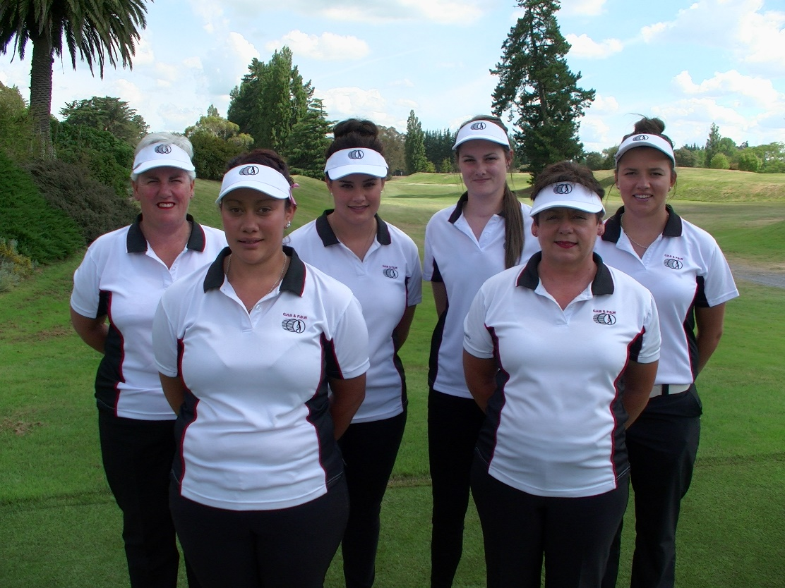
Kathy Olsen, Sara Deam, Kate Chadwick, Jaimie McIvor, Sue Sowerby, Lucy Owen

